

Medium Level Programs (1-10)

Date – 10/03/2026

Name: M. Sahasra
Reg. No.: 192425317
Course Code: CSA0919
Course Name: Programming in Java for Spring Framework
Faculty Name: Dr. Magesh Kumar

- Count Prime and Composite Numbers

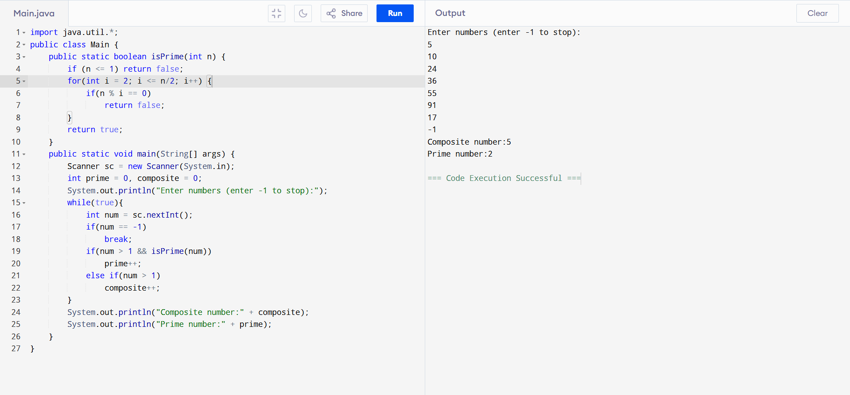

- Mth Maximum and Nth Minimum

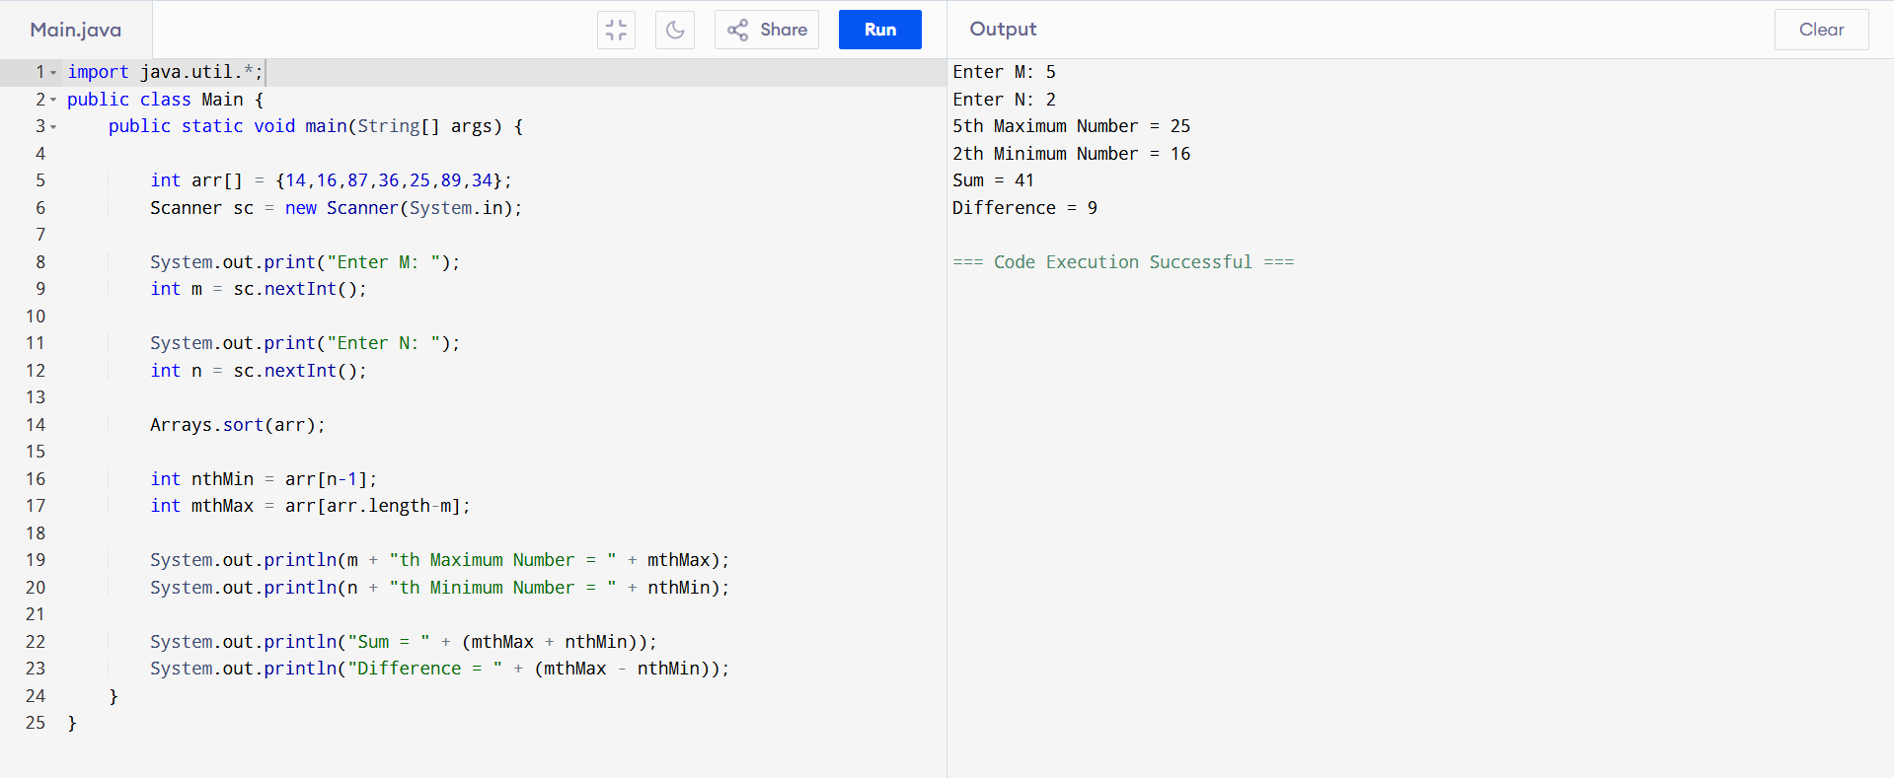
3. ATM Balance Calculation
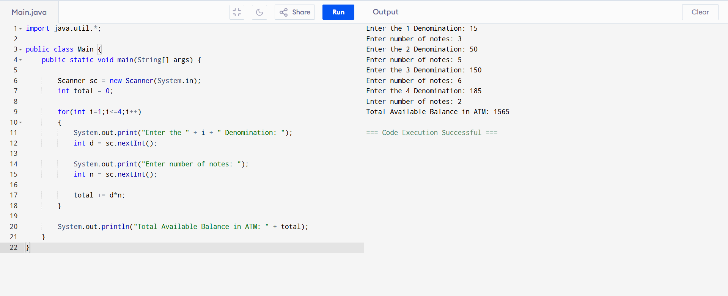
4. Palindrome (String or Number)
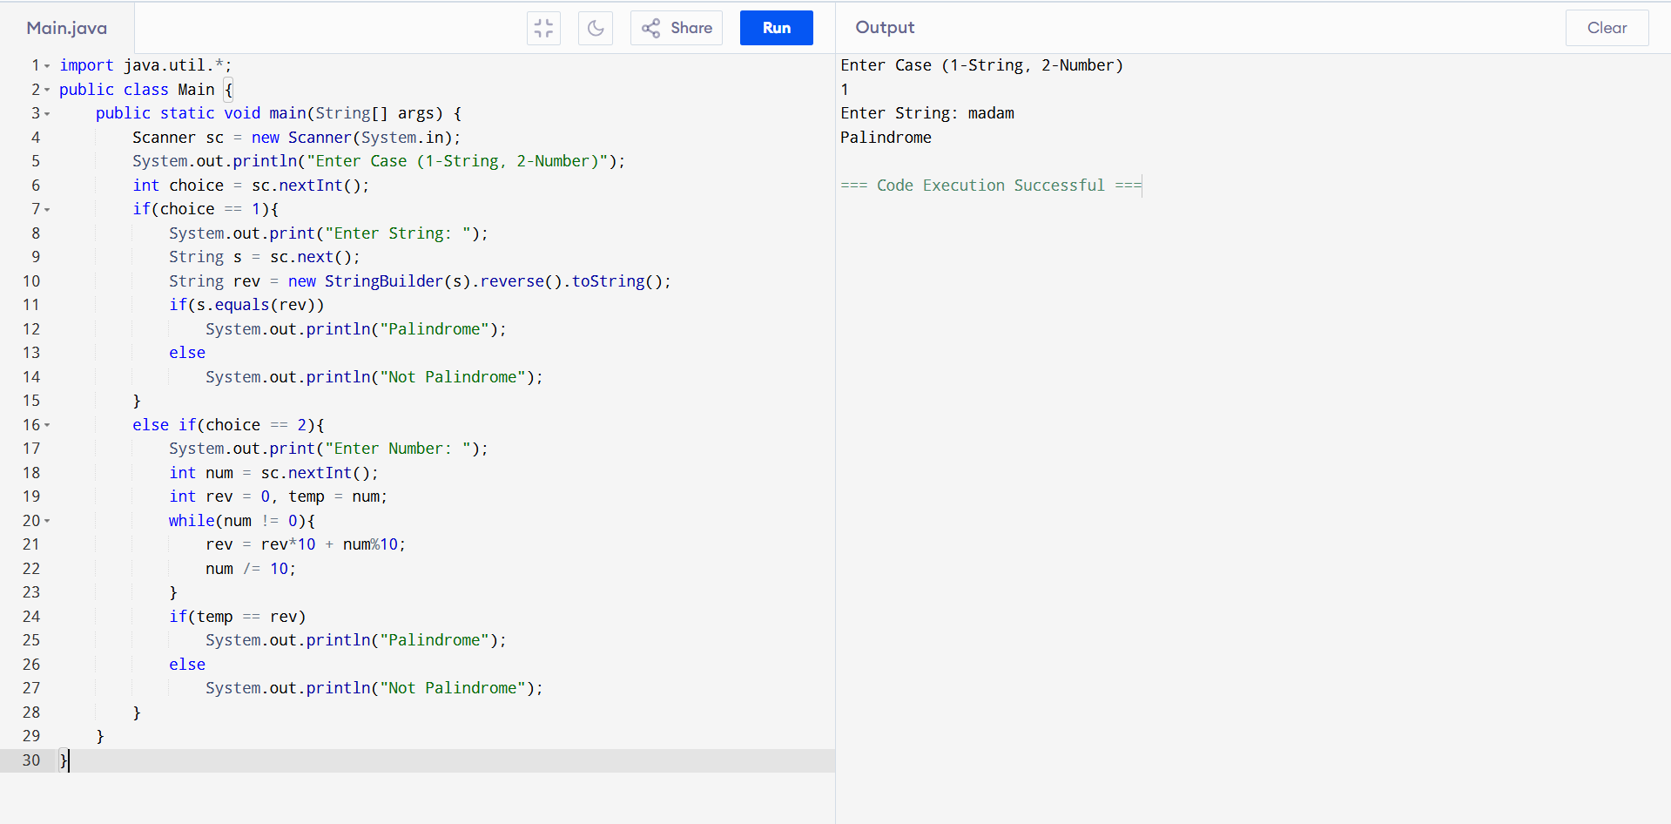
5. Decimal to Binary and Octal
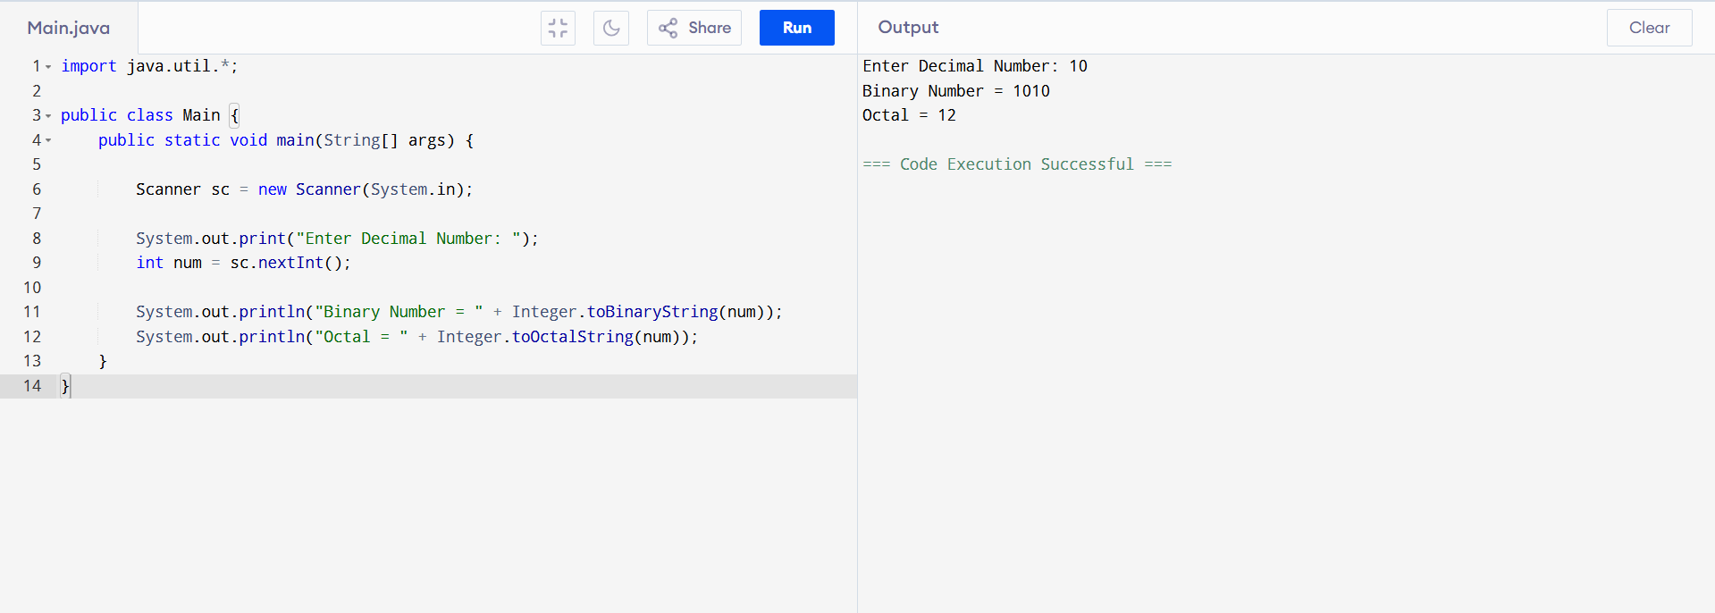
6. Employee Bonus
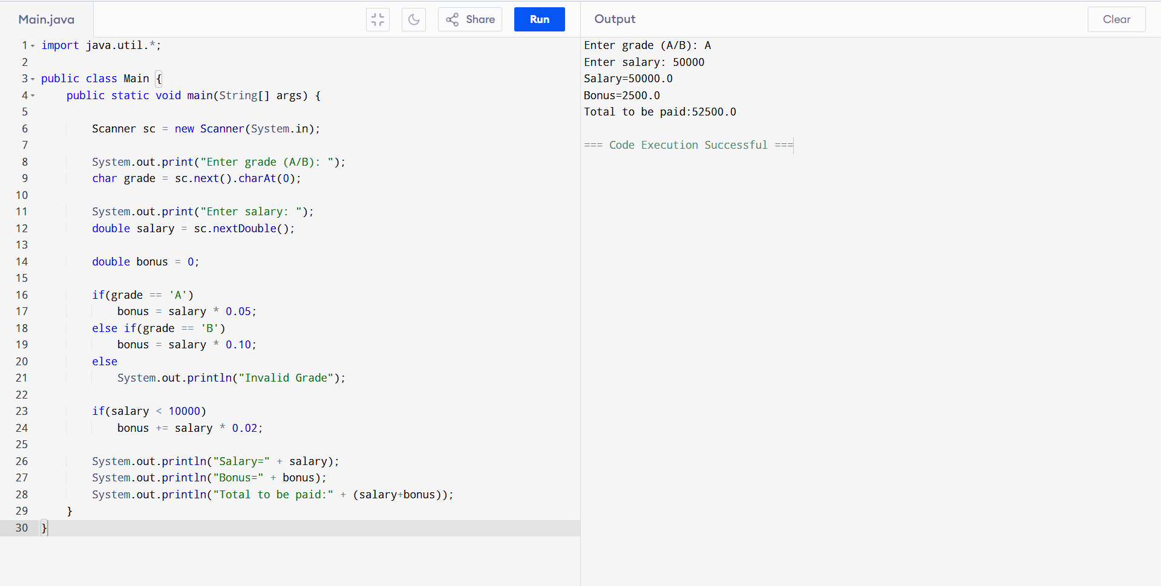
7. First N Perfect Numbers
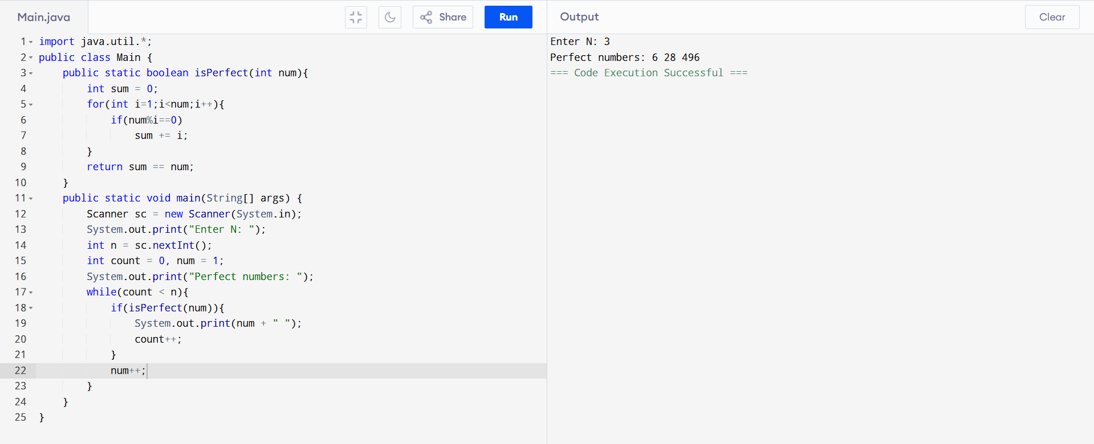

8. Student Grade

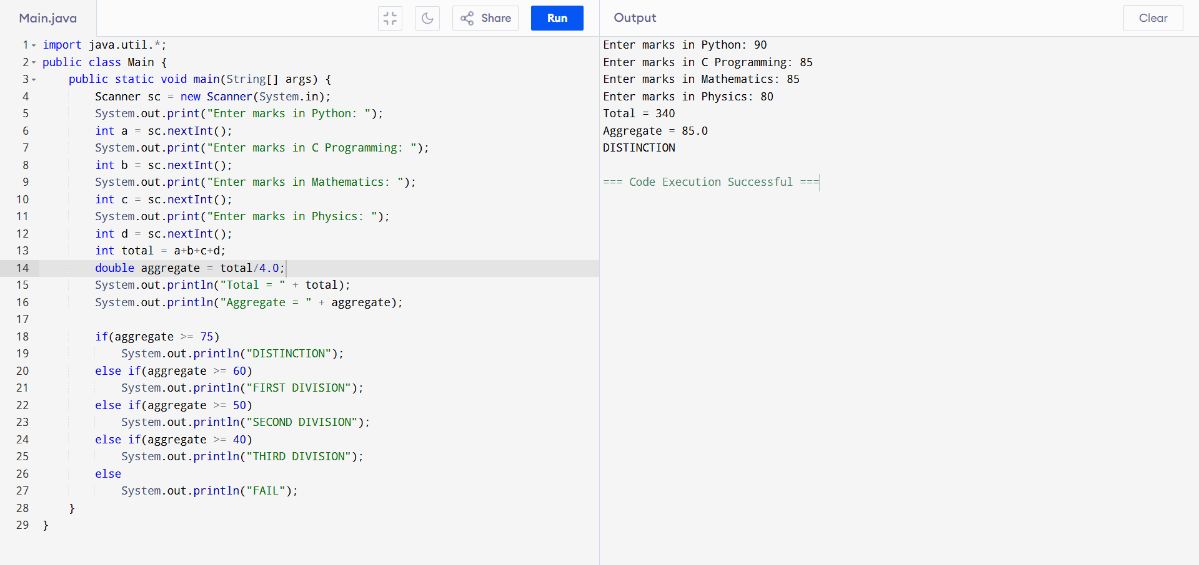

9. Average of Positive and Negative Numbers

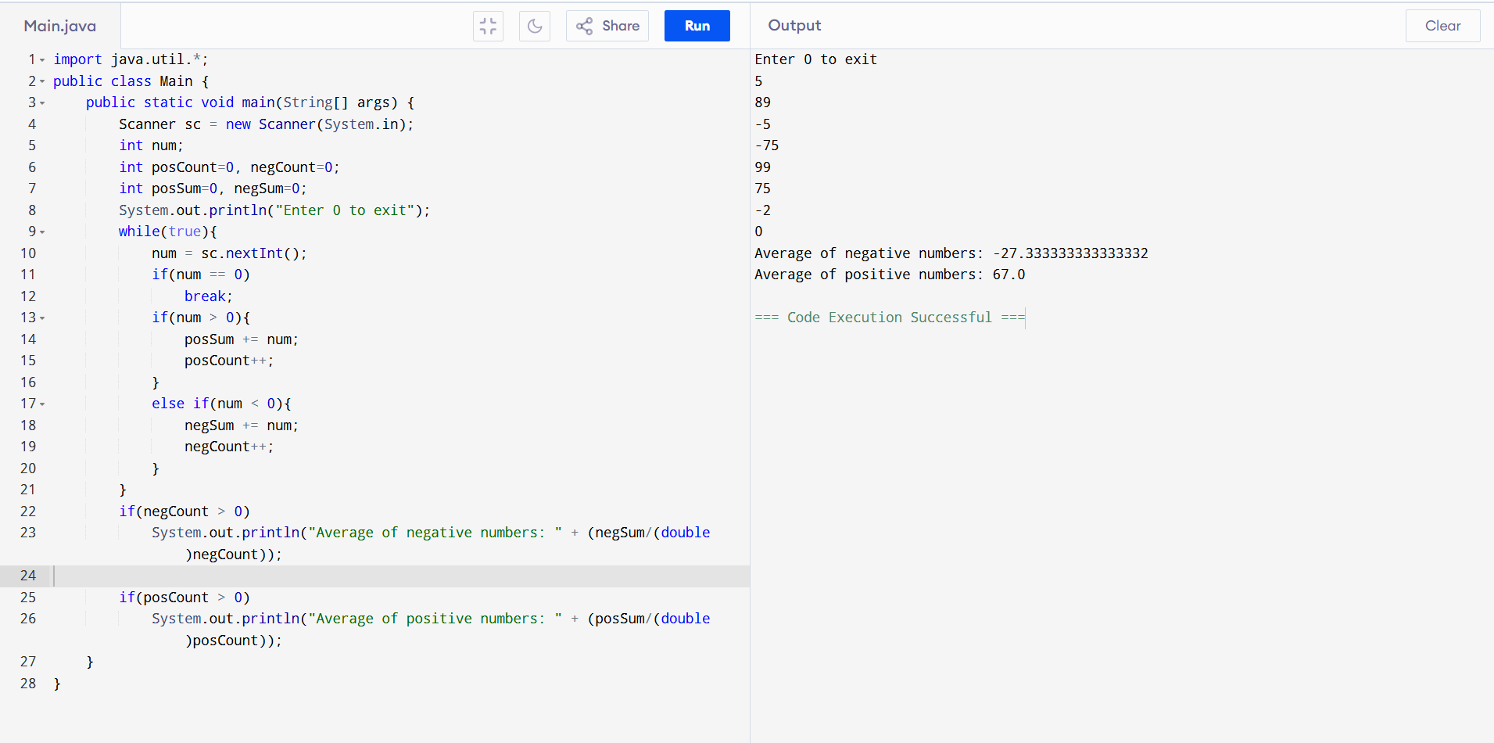

10. Count Uppercase, Lowercase, Numbers
